Tabari Harvey Module 1.2 Assignment: GitHub Repository Setup

1. <https://github.com/MurphT4stic/csd-325>
2. 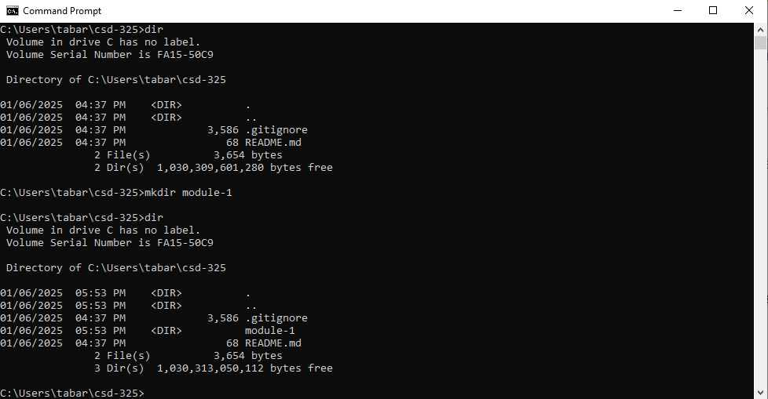
3. 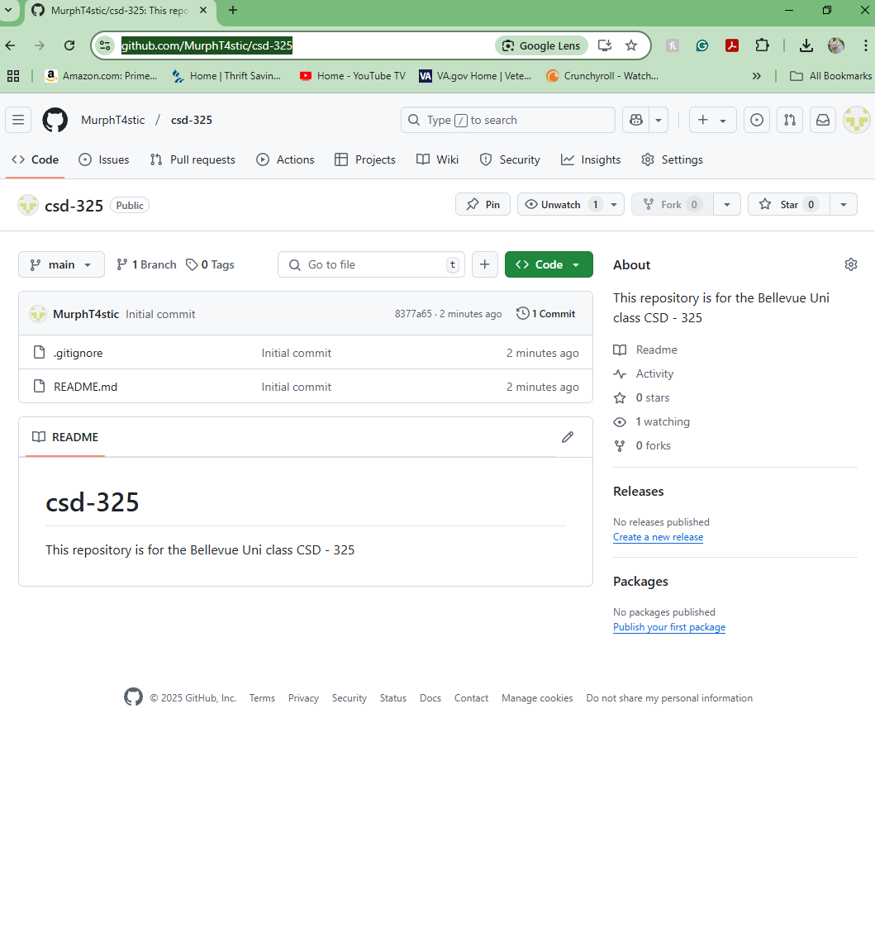
4. 